How Ground Feeders Benefit Your Horse
Drs. Foster & Smith Educational Staff
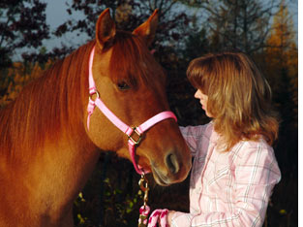 | 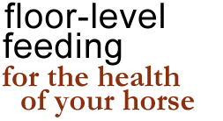
 | Many horse owners are diligent about their mount's nutritional needs. They search for the right combination of forage, grain, and
supplements. The result, they hope, is a horse or pony that lives healthier, runs faster, works longer, and moves sounder. But there is more to your horse's health than the perfect diet. In fact, how your horse is fed can influence his health almost as much as the types of foods he eats.
types of equine feeders
There are a variety of horse feeders available. Hay racks, mangers, feed bins and bags, concentrate feeders, and more are each designed to help your horse get the nutrients and variety he needs for a healthy life. Each style of feeder has its advantages. Some, like wall feeders, elevate food to help prevent fecal, dirt, and bedding contamination. Others, such as hay bags, are perfect for use in trailers while traveling to competitions or shows.
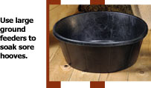
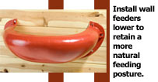
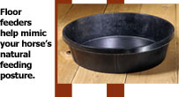

But care needs to be taken with all feeder types. Hay bags that are hung too low, for instance, can tangle your horse's feet when empty. Similarly, metal concentrate feeders can wear over time and the resulting sharp edges can cut your horse's neck, chin, tongue, or lips. However, it is the height at which most of these feeders are installed that poses the greatest health risk for your horse.
Hay racks, suspended concentrate feeders, and others are often installed above your horse's withers. This helps prevent him from becoming tangled in the feeder or wounded by its components should he panic while in the stall. But when feeders are elevated to this height, horses are forced to reach upwards to obtain their food. This posture causes an increase of inhaled dust and hay particles, which can cause respiratory distress. It also puts unnecessary strain on your horse's neck. Worse, this position can cause your horse to choke, may contribute to colic, and helps decrease the amount of nutrients your horse obtains from his food.
the natural feeding posture
Wild horses graze vast grass and pasturelands for food. As a result, most of their food is consumed in a heads down position. Floor-level feeding mimics this natural posture and has many health benefits, including:
Slowed Consumption - Horses are more relaxed while eating off the ground. As a result, they take smaller mouthfuls of food, more thoroughly chew it, and better mix it with saliva, which helps reduce the risk of choking and impaction colic.
Improved Nutrition - Since horses chew more and the hay or grain mixes better with saliva, food is better prepared for breakdown in the digestive tract. As a result, more vitamins, minerals, and nutrients are absorbed from the food.
Reduced Irritants - Your horse inhales less irritants when he eats with his head down. He also reduces the risk of irritants falling into his eyes. A lowered head also promotes airway drainage, which helps flush out any inhaled dust or hay particles.
encourage safe floor-level feeding
The best way to encourage your horse's natural feeding posture and promote better health is to feed him at ground level. However, your horse's health can be compromised if hay or grain is simply placed on the stall floor or ground where it can mix with waste, sand, and parasite eggs. Instead, use a ground-level feed tub to help protect your horse's food from contamination and promote a more natural grazing posture.
To further protect your horse from insect and parasite eggs, use an appropriate insect control and dewormer regimen. Also keep in mind that the best feed pans are constructed of durable, yet flexible, crack- and chew-resistant reinforced rubber. This helps prevent injury should your horse become agitated while in the stall or run-in shelter, but withstands years of use for added protection to your pocketbook.
If you still prefer to elevate your horse's food with a wall feeder, install the feeder at a lower height to ease access for your horse and retain more of a natural feeding posture. Also, look for designs with smooth, rounded edges and reinforced mounting holes for added safety.
Of course, the simplest way to encourage ground-level feeding is by offering your horse access to an appropriate lush pasture or paddock. Thankfully, today's economical electric fence kits and accessories permit you to build a pasture or paddock that suits all of your horse's grazing needs.

